**HTML/CSS Exercise**

**Part 1:**

Open the link on Google Classroom to the Codepad.app program and click remix to get your own version of the project.

Use tags such as headings (<h1>, <h2> ), paragraphs (<p>), line breaks (<br>) and links (<a href) to format the text to look like the following:

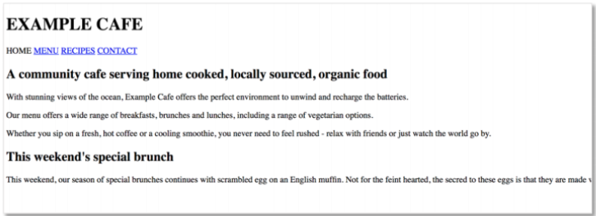

**Part 2:**

There is a second html file in your project called Recipe.html. When you click on the Recipe link in your index page, it should take you to this page.

Format your page to look like this. Remember lists can be made using <ol> or <ul>

<ol> is an ordered list which will have numbers.

<ul> is an unordered list which will have bullet points.

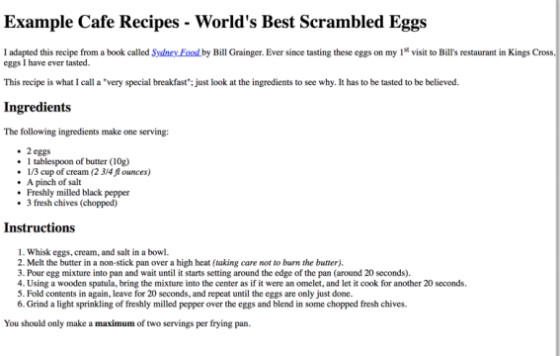

**Part 3:**

Create a new HTML file in your project. Your new page should look something (don’t worry about heading font) like this.

When you click on the Contact link on your index page, it should link to this page.

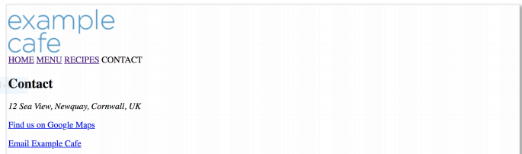

**Part 4:**

Add an image to your Home page.

**Part 5: CSS**

Now you need to make your page look better using CSS. Use the style.css for your CSS code.

Add background colour, different fonts etc.

You can add some CSS to your pictures - [See here](https://www.101computing.net/html-using-css-with-pictures/)